* 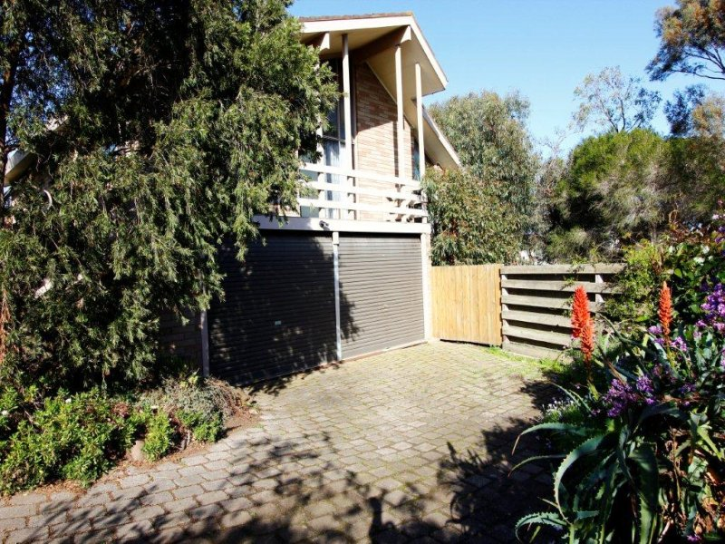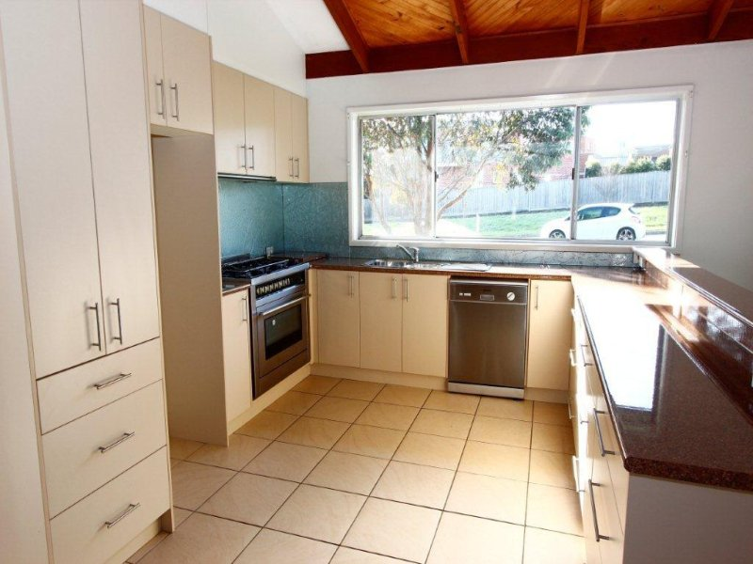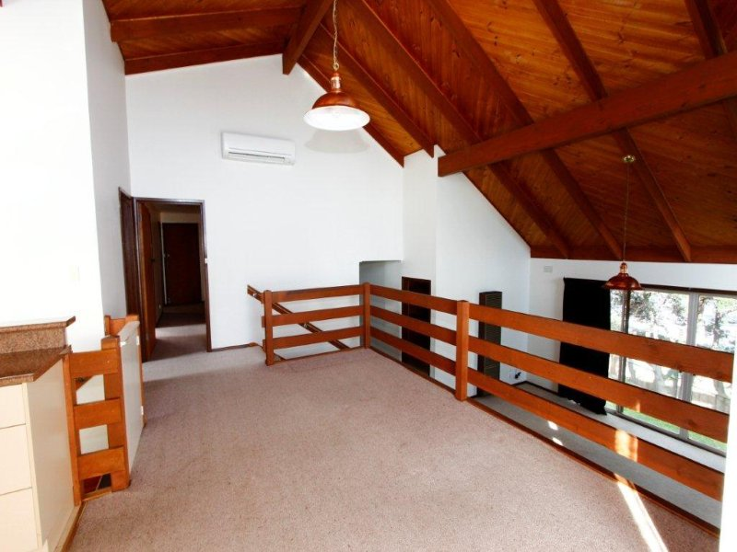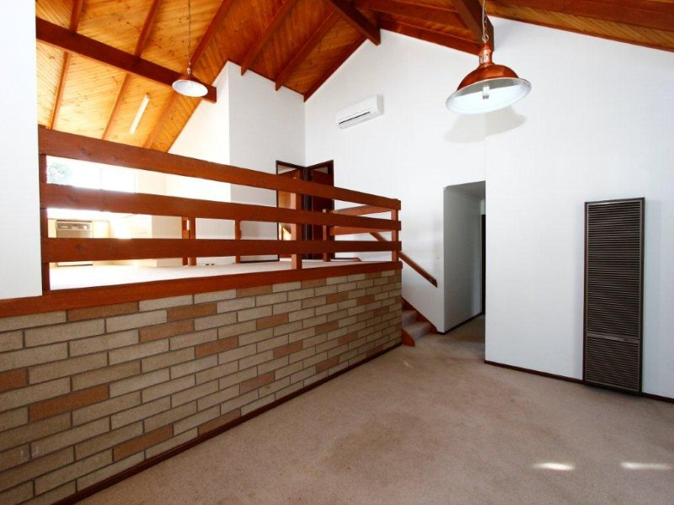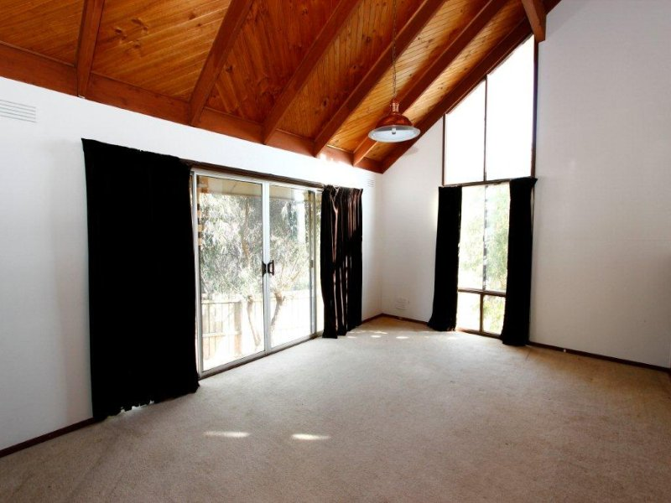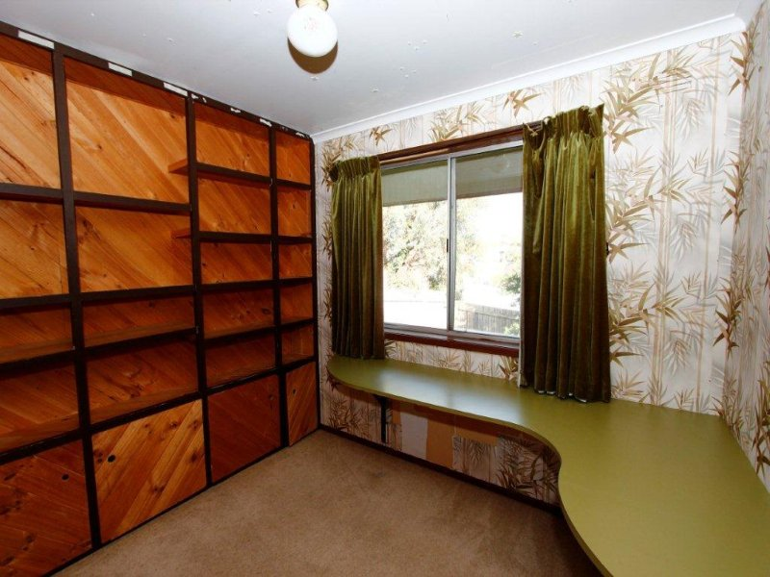$390 per week

- Front deck into entrance  
- Large open kitchen and dining with gas cook top, electric oven and dishwasher – all stainless steel  
- Ample bench and cupboard space throughout the kitchen  
- Split system heating and cooling and gas heating  
- Split level dining and lounge, high ceilings and overlooks the leafy yard  
- Huge master bedroom with walk in robe  
- Additional bedrooms with built in robes  
- Centrally located main bathroom with bath, separate shower and toilet  
- Generous separate laundry  
- Substantial rumpus on the bottom story with access from the garage  
- Off Street parking and double roller door garage  
- Easy to maintain yard which takes advantage of the winter sun with garden beds – all enclosed